FAST diagram
To help you develop a functional analysis diagram, Appvizer gives you a FAST diagram template as well as a reminder of the steps to build it on the second page.

It’s up to you to complete it with information about your project!

More info: https://www.appvizer.com/magazine/operations/project-management/fast-diagram

Blank FAST diagram template

Template to print
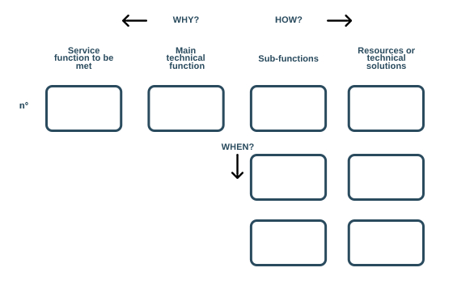

Table template to complete with Word

 | ← Why | How →
N°1 Service function | N*1 Main technical function | N°1 Sub-function | Resources or technical solutions
N°1 Service function | N*1 Main technical function | N°2 Sub-function | Resources or technical solutions
N°1 Service function | N*1 Main technical function | N°3 Sub-function | Resources or technical solutions
N°1 Service function | N*1 Main technical function | N°4 Sub-function | Resources or technical solutions
N°1 Service function | N*2 Main technical function | Sub-function | Resources or technical solutions
N°2 Service function | Main technical function | Sub-function | Resources or technical solutions

A reminder of the steps to build a FAST diagram
- Do a functional analysis first

- List all the functions of a product, for example, for a washing machine: wash clothes, rinse clothes, spin clothes,
- Detail these functions, prioritize them and value them (high or low importance),
- Identify the main functions (removing stains), the secondary functions (softening the laundry) and the constrained functions (not damaging the laundry),

- For each function identified:

- You should ask yourself "How is this function accomplished?" and write the answer to the right, in the form of an active verb and a noun designating something measurable,
- And then, you should wonder "Why develop this function?" and write the answer on the left,

- For each logic problem in the scenario, identify missing or redundant functions or adjust the order of functions.

- Identify those that occur simultaneously or depend on each other, by asking "when this function is performed, does another function trigger? Or does it depend on the triggering of another function?" and write the answer below.

Comments
- Use this template according to your needs, there is no such thing as a typical FAST diagram
- For more customization, use an adapted software

